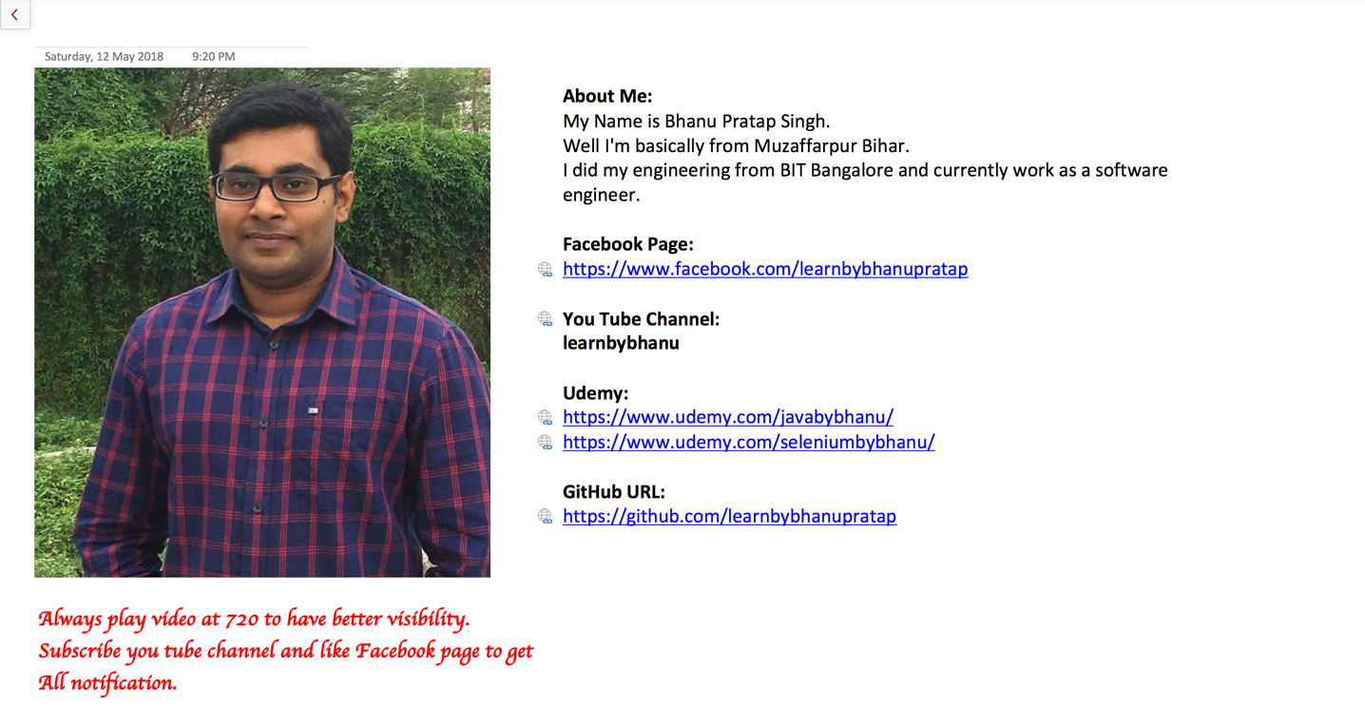

**What is Locator?**

The locator can be termed as an address that identifies a web element uniquely within the webpage. Locators are the HTML properties of a web element which tells the Selenium about the web element it needs to perform the action on.

Selenium webdriver uses 8 locators to find the elements on web page. The following are the list of object identifier or locators supported by selenium.

**We have prioritized the list of locators to be used when scripting.**

**id***Select element with the specified****@id****attribute.*

**Name***Select first element with the specified****@name****attribute.*

**Linktext***Select link (anchor tag) element which contains text matching the specified link text*

**Partial Linktext***Select link (anchor tag) element which contains text matching the specified partial link text*

**Tag Name***Locate Element using a Tag Name .*

**Class name***Locate Element using a class Name ..*

**Css** *Select the element using css selectors.*

**Xpath***Locate an element using an XPath expression.*

**X Path**

**Syntax**

// TagName[@Attribute Name=’attribute Value’]

**Types of X Path**

1. **Native Xpath,** it is like directing the xpath to go in direct way. like  
   **Example:**  
   html/head/body/table/tr/td
2. **Relative Xpath.**

In relative xpath we will provide the relative path, it is like we will tell the xpath to find an element by telling the path in between.  
Advantage here is, if at all there is any change in the html that works fine, until unless that particular path has changed. Finding address will be quite difficult as it need to check each and every node to find that path.  
**Example:**  
//table/tr/td

**For CSS**

|  |  |
| --- | --- |
| **Attribute** | **Symbol Used** |
| **User ID** | use # symbol |
| **Using Class Name** | Use . symbol |
| **Using attribute** | tagname[attribute='value'] |
| **Using Multiplr attribute** | tagname[attribute1='value1'][attribute2='value2'] |
| **Contains** | *symbol |
| **Starts with** | ^ symbol |
| **Ends with** | $ sybmol |

Application URL:

[**https://www.facebook.com/**](https://www.facebook.com/)**?**

**HTML**

**<input type="email" class="inputtext" name="email" id="email" value="" tabindex="1" data-testid="royal_email">**

**X Path**

//input[@id='email']

//input[@class='inputtext' and @id='email']

//input[@name='email']

//input[@data-testid='royal_email']

**CSS:**

#email

input[id='email']

input[class='inputtext'][id='email']

input[name='email']

input[data-testid='royal_email']

**HTML**

**<input type="password" class="inputtext" name="pass" id="pass" tabindex="2" data-testid="royal_pass">**

**X Path**

//input[@type='password' and @name='pass']

//input[@id='pass']

//input[@data-testid='royal_pass']

//input[@data-testid='royal_pass' and @id='pass' and @name='pass']

**CSS**

input[type='password'][name='pass']

#pass

input[data-testid='royal_pass']

input[data-testid='royal_pass'][id='pass'][name='pass']

**HTML**

**<div class="_ihd _3ma mbs _6n _6s _6v">Create a new account</div>**

**X Path**

//div[text()='Create a new account']

**HTML**

**<input type="text" class="inputtext _58mg _5dba _2ph-" data-type="text" name="reg_email__" aria-required="1" placeholder="" aria-label="Mobile number or email address" id="u_0_q" role="button">**

**X Path:**

//input[@name='reg_email__']

//input[@aria-label='Mobile number or email address']

**CSS:**

input[name='reg_email__']

input[aria-label='Mobile number or email address']

input[class^='inputtext'][name='reg_email__']

input[aria-label$='or email address']

**HTML**

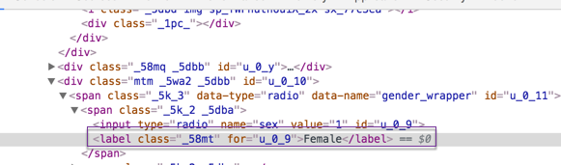

**X Path**

//span[@data-name='gender_wrapper']/span[1]/label

//label[contains(text(),'Female')]

**CSS**

span[data-name='gender_wrapper']>:nth-child(1)>:nth-child(2)

**HTML:**

**<a class="_58ms mlm _5f0v" id="birthday-help" href="#" title="Click for more information" role="button" aria-describedby="js_uh" tabindex="0">Why do I need to provide my date of birth?</a>**

**X Path**

//a[@title='Click for more information']

//a[@id='birthday-help']

//a[contains(text(),'Why do I need to provide my date of birth?')]

**CSS:**

a[title='Click for more information']

#birthday-help

**Application URL:**

[**https://www.seleniumhq.org/download/**](https://www.seleniumhq.org/download/)

**HTML**

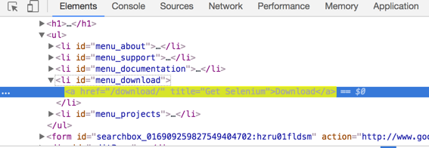

**Download**

**X Path**

//a[@href='/download/' and @title='Get Selenium']

//a[@title='Get Selenium']

//li[@id='menu_download']/a

**CSS**

a[href='/download/'][title='Get Selenium']

a[title='Get Selenium']

li[id='menu_download']>a

#menu_download>a

**HTML**

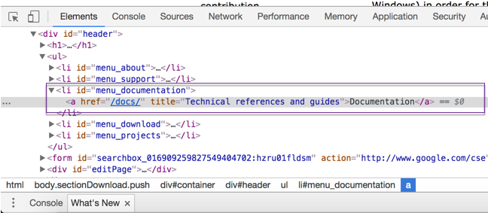

**Documentation**

**X Path**

//a[@href='/docs/' and @title='Technical references and guides']

//a[@title='Technical references and guides']

//li[@id='menu_documentation']/a

**CSS**

a[href='/docs/'][title='Technical references and guides']

a[title='Technical references and guides']

li[id='menu_documentation']>a

#menu_documentation>a

**How to get all common li**

**HTML**

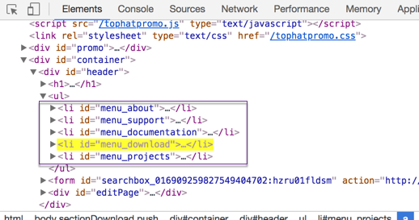

**X Path**

//div[@id='header']/ul/li

**CSS**

div[id='header']>ul>li

**HTML**

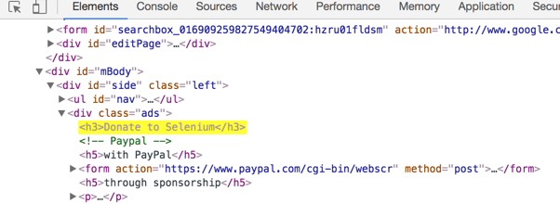

**Donate to Selenium**

**X Path**

//h3[contains(text(),'Donate to Selenium')]

//div[@class='ads']/h3[contains(text(),'Donate to Selenium')]

//div[@id='mBody']/div/div[1]/h3[1]

//h3[text()='Donate to Selenium']

**CSS**

.ads>:nth-child(1)

#mBody>:nth-child(1)>:nth-child(2)>:nth-child(1)

**Application URL:**

[**https://www.actitime.com/download**](https://www.actitime.com/download)

**HTML:**

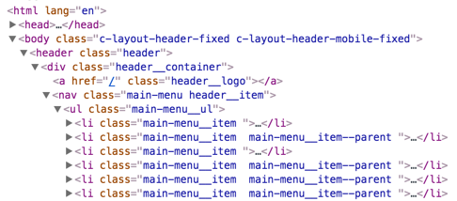

**How to get all li through reference of Parent Node**

**X Path:**

//div[@class='header__container']/nav/ul/li[1]

//div[@class='header__container']/nav/ul/li[2]

//div[@class='header__container']/nav/ul/li[3]

//div[@class='header__container']/nav/ul/li[4]

**CSS:**

.header__container>nav>ul>:nth-child(1)

.header__container>nav>ul>:nth-child(2)

.header__container>nav>ul>:nth-child(3)

.header__container>nav>ul>:nth-child(4)

**HTML:**

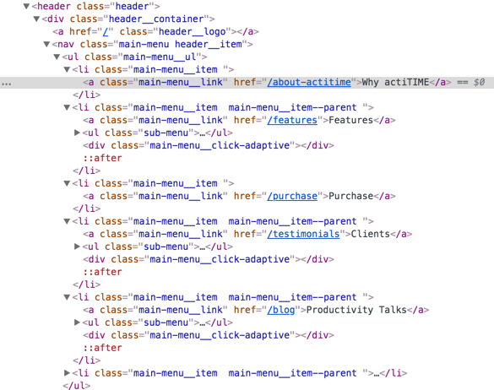

**Following-Sibling, Preceding-sibling, Child, Parent Concepts in Selenium**

**Child Example:**

X path

**To Locate nav in HTML**

//div[@class='header__container']/child::nav

**To Locate ul in HTML**

//div[@class='header__container']/child::nav/child::ul

**To Locate third li in HTML**

//div[@class='header__container']/child::nav/child::ul/child::li[3]



**Following sibling example**

**To Locate Features**

//a[contains(text(),'Features')]

**To Locate Purchase with Reference of Features**

//a[contains(text(),'Features')]/parent::*/following-sibling::li[1]/a

**To Locate Clients with Reference of Features**

//a[contains(text(),'Features')]/parent::*/following-sibling::li[2]/a

**Preceding sibling example**

**To Locate Clients**

//a[contains(text(),'Clients')]

**To Locate Features with Reference of Clients**

//a[contains(text(),'Clients')]/parent::*/preceding-sibling::li[2]/a

**To Locate Purchase with Reference of Clients**

//a[contains(text(),'Clients')]/parent::*/preceding-sibling::li[1]/a

**Application:**

[**https://book.spicejet.com/Register.aspx**](https://book.spicejet.com/Register.aspx)

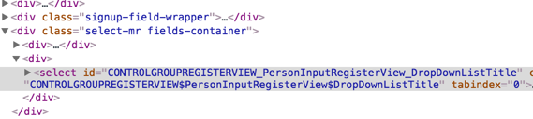

**CSS**

**start-with**

select[name^='CONTROLGROUPREGISTERVIEW$PersonInput']

select[name^='CONTROLGROUPREGISTERVIEW$PersonInput']

**ends-with**

select[name$='PersonInputRegisterView$DropDownListTitle']

select[name$='PersonInputRegisterView$DropDownListTitle']

**X Path**

//select[starts-with(@id,'CONTROLGROUPREGISTERVIEW')]

**Application:**

[**https://www.tirerack.com/content/tirerack/desktop/en/homepage.html**](https://www.tirerack.com/content/tirerack/desktop/en/homepage.html)

|  |  |
| --- | --- |
| Elements | X Path |
| Tires | //*[@id='pageLinks']/ul/li[1]/div/div/a |
| Wheels | //*[@id='pageLinks']/ul/li[2]/div/div/a |
| Parts & Accessories | //*[@id='pageLinks']/ul/li[3]/div/div |
| Research & Advice | //*[@id='pageLinks']/ul/li[4]/div/div/a |
| Delivery & Installation | //*[@id='pageLinks']/ul/li[5]/div/div/a |
| Why Tire Rack? | //*[@id='header']/div/div[1]/div/div[2]/ul/div/li[1]/a |
| Order Tracking | //*[@id='header']/div/div[1]/div/div[2]/ul/div/li[2]/a |
| Customer Support | //*[@id='header']/div/div[1]/div/div[2]/ul/div/li[3]/a |
| phoneNumber | //*[@id='phoneNumber'] |
| Log In / Create Account | //*[@id='header']/div/div[1]/div/div[2]/ul/li[1]/div/div[2]/div |
| Select Make | //*[@id='shopByVehicle-search-change']/div[1]/div[1]/button |
| Select Year | //*[@id='shopByVehicle-search-change']/div[1]/div[2]/button |
| Select Model | //*[@id='shopByVehicle-search-change']/div[1]/div[3]/button |
| zipCheck | //*[@id='shopByVehicle-search-change']/div[4]/input |
| Choose Your Product Category | //*[@id='shopByVehicle-search-change']/div[7]/div/div/button |

|  |  |
| --- | --- |
| Elements | CSS |
| Tires | #pageLinks>ul>:nth-child(1)>div>div>a |
| Wheels | #pageLinks>ul>:nth-child(2)>div>div>a |
| Parts & Accessories | #pageLinks>ul>:nth-child(3)>div>div>a |
| Research & Advice | #pageLinks>ul>:nth-child(4)>div>div>a |
| Delivery & Installation | #pageLinks>ul>:nth-child(5)>div>div>a |
| Why Tire Rack? | .utilitynav.utility-nav>:nth-child(1)>a |
| Order Tracking | .utilitynav.utility-nav>:nth-child(2)>a |
| Customer Support | .utilitynav.utility-nav>:nth-child(3)>a |
| phoneNumber | #phoneNumber |
| Log In / Create Account | .log |
| Select Make | .select4Set.clearafter>:nth-child(1)>button>div |
| Select Year | .select4Set.clearafter>:nth-child(2)>button>div |
| Select Model | .select4Set.clearafter>:nth-child(3)>button>div |
| zipCheck | .zip-code.zip-code-input |
| Choose Your Product Category | .row.oneField>div>div |

**Application**

[**https://www.facebook.com/**](https://www.facebook.com/)**?**

**CSS**

|  |  |
| --- | --- |
| Facebook |  |
| First Name | input[name='firstname'] input[class^="inputtext"][name="firstname"] |
| Surname | input[name='lastname'] |
| Mobile Numer or Email Address | [aria-label="Mobile number or email address"] |
| Re-enter Mobile Number | [type="text"][aria-label="Re-enter mobile number or email address"] |
| New Password | [type="password"][aria-label="New password"] |
| Day | #day [title="Day"][name="birthday_day"][aria-label="Day"] |
| Month | [title="Day"][name="birthday_day"][aria-label="Day"]+select |
| Year | [title="Day"][name="birthday_day"][aria-label="Day"]+select+select |
| Why doo I need to provide my DOB | [title$="more information"] |
| Female | span[data-name="gender_wrapper"]>:nth-child(1)>:nth-child(2) |
| Male | span[data-name="gender_wrapper"]>:nth-child(2)>:nth-child(2) |
| **Female** | **span[data-name="gender_wrapper"]>:first-child** |
| **Male** | **span[data-name="gender_wrapper"]>:last-child** |